Fax
To: | FEMA Individuals and Households Program | From: | Applicant First M. Last
Fax: | 800-827-8112 | Fax: | 606-###-####
Phone: | 800-621-3362 | Phone: | 606-###-####
Subject: | Housing Assistance Appeal Letter | Date: | Month Day, 2025
No. Pages: | ____ (Including Cover Sheet)

Comments:

Applicant Name: Applicant First M. Last
FEMA Registration No.: 6########
Disaster No.: DR-4860-KY (Kentucky Severe Storms, Straight-line Winds, Flooding, Landslides, and Mudslides)
Pre-disaster Address: Physical address, City, County, KY Zip
Post-disaster Address: Physical address, City, County, KY Zip
Mailing Address: Mailing address, City, County, KY Zip
Applicant Phone No.: 606-###-####
Date of Appeal: Month Day, 2025

Attachments:
- Signed Release of Information Form
- Housing Assistance Appeal Letter
- Statement of No Homeowners Insurance

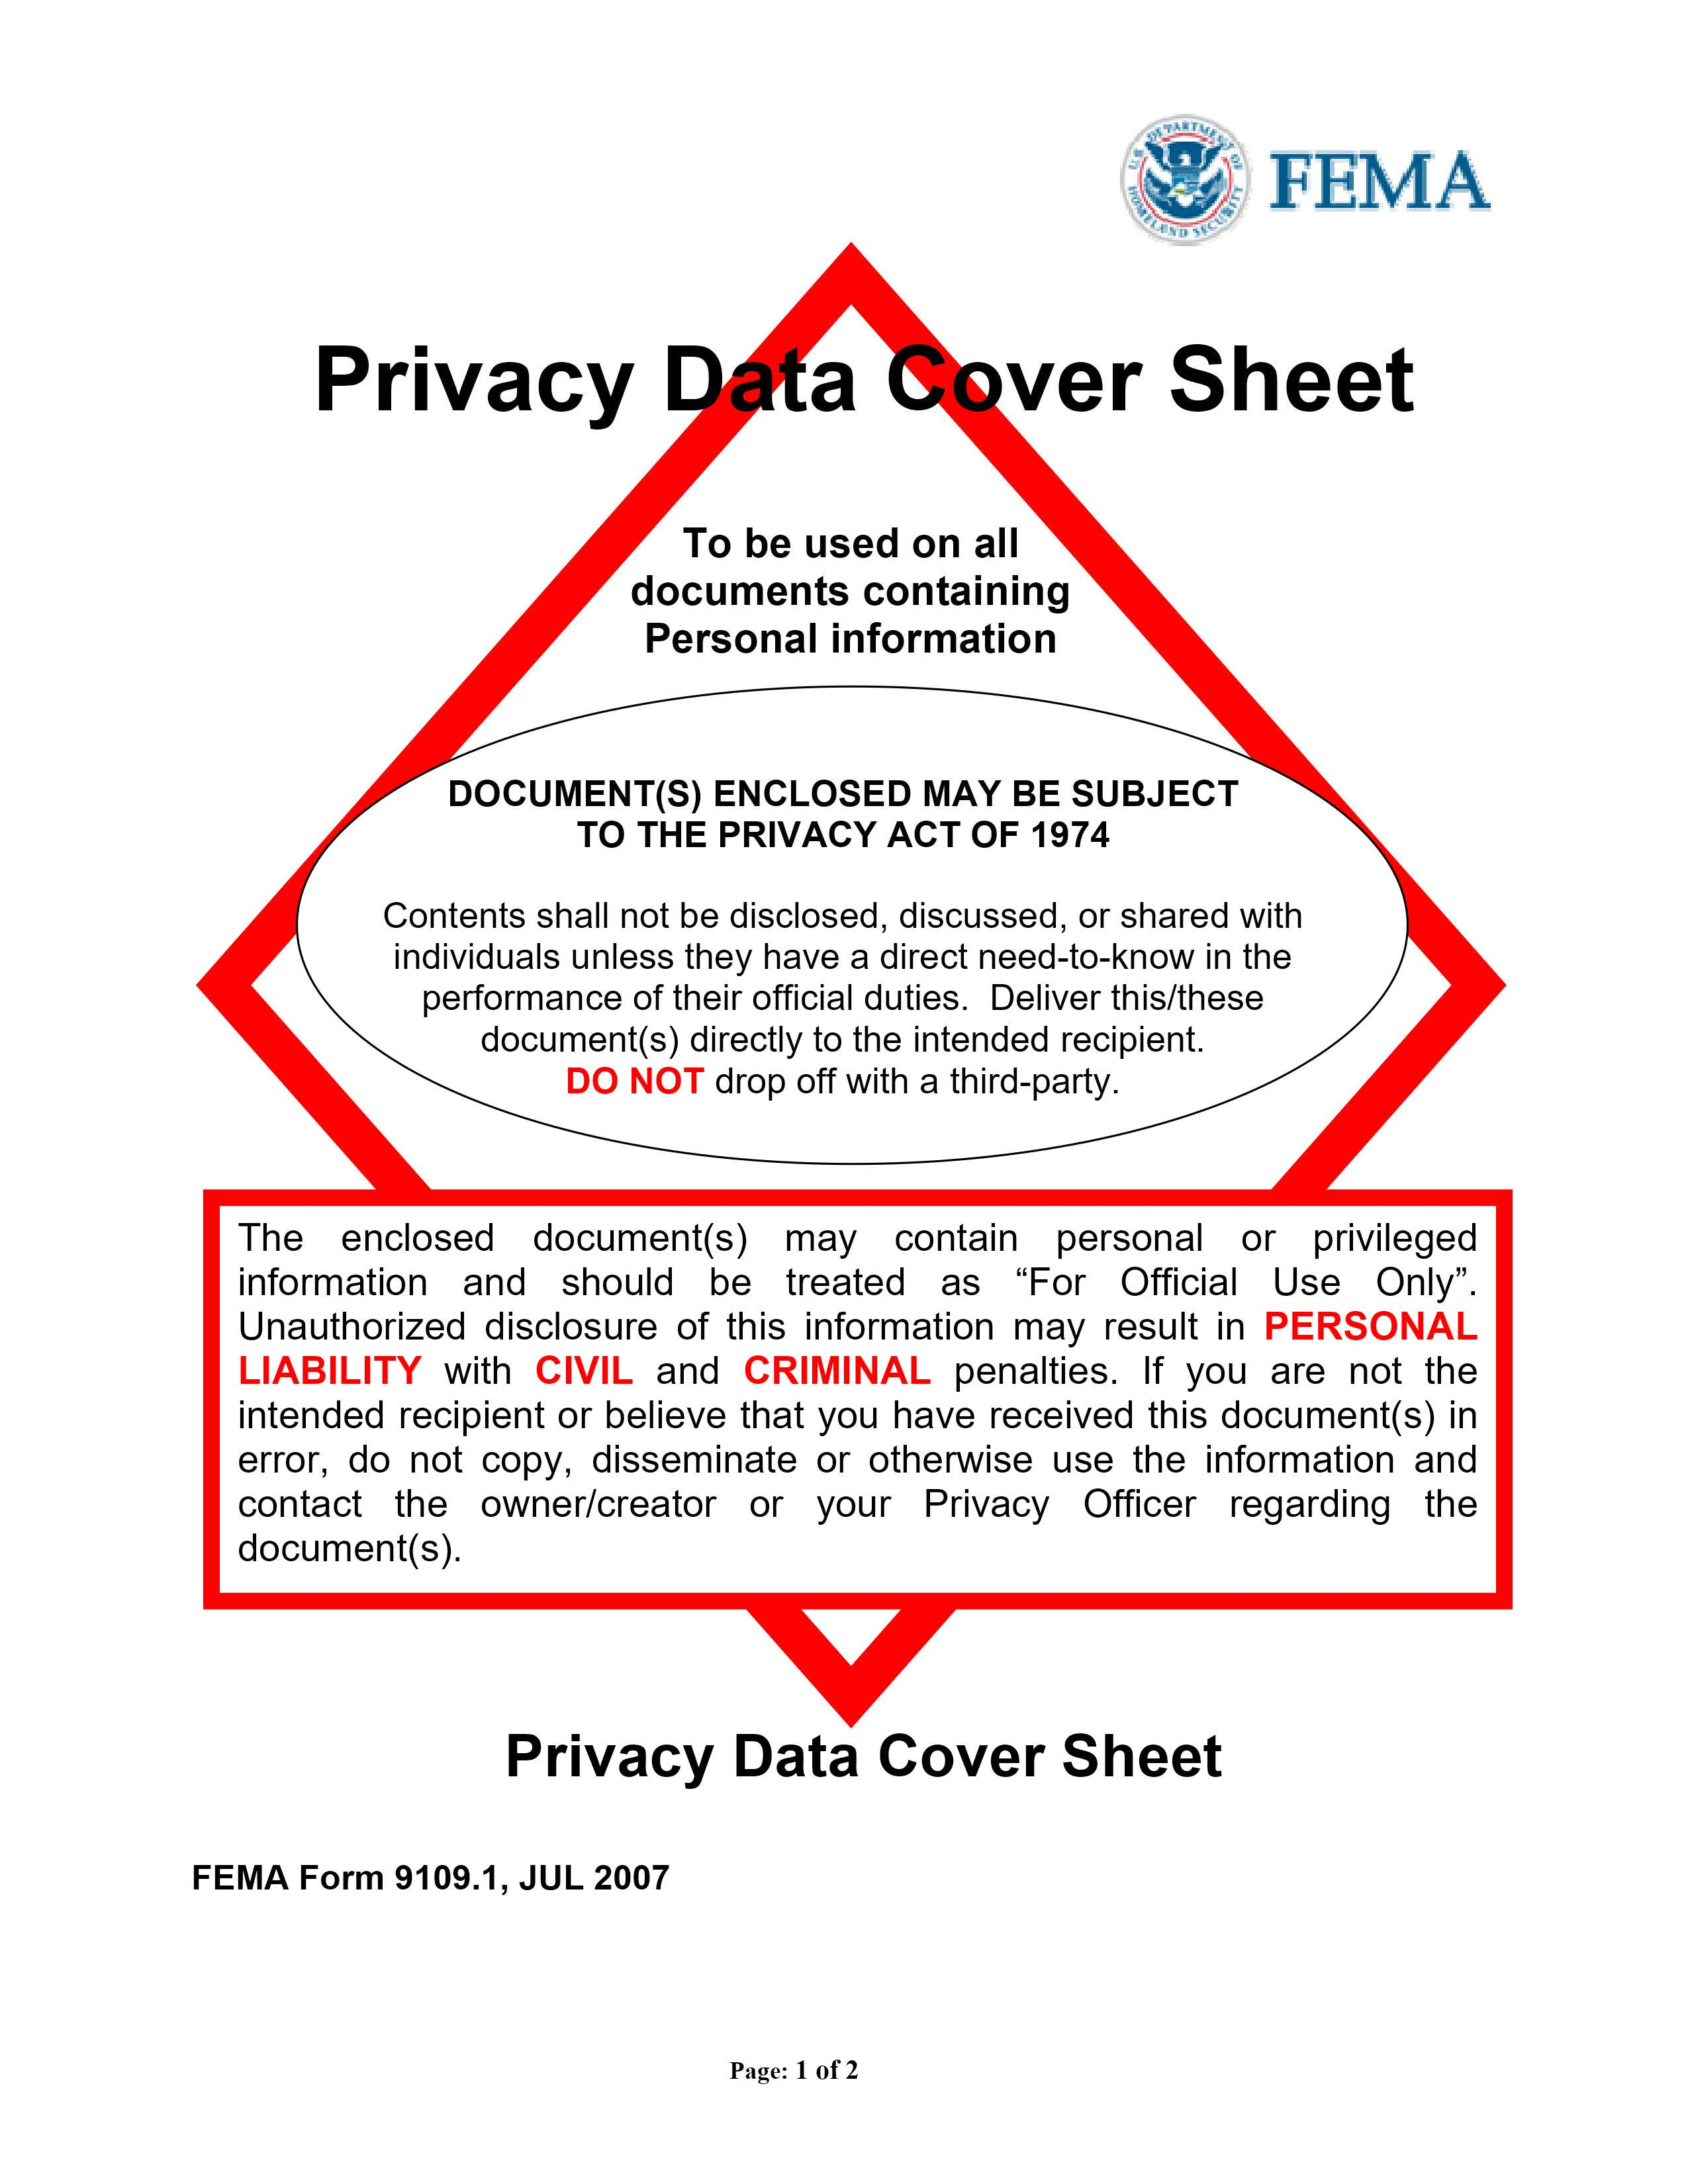

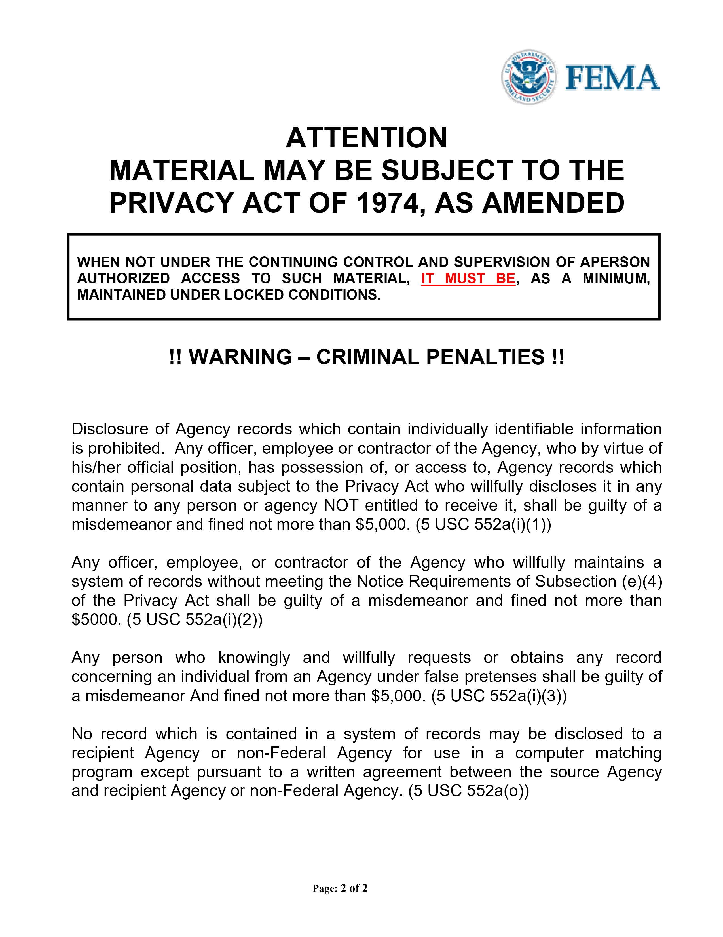

Remove this page before submitting

Insert signed FEMA Release of Information pages (2)

FEMA Release of Information form:
https://www.fema.gov/sites/default/files/documents/fema_form_ff-104-fy-21-118.pdf

Applicant Name: Applicant First M. Last
FEMA Registration No.: 6########
Disaster No.: DR-4860-KY (Kentucky Severe Storms, Straight-line Winds, Flooding, Landslides, and Mudslides)
Pre-disaster Address: Physical address, City, County, KY Zip
Post-disaster Address: Physical address, City, County, KY Zip
Mailing Address: Mailing address, City, County, KY Zip
Applicant Phone No.: 606-###-####
Date of Appeal: Month Day, 2025

HOUSING ASSISTANCE APPEAL LETTER

FEMA,

I, Applicant First M. Last, am appealing the amount/denial that I received for FEMA Housing Assistance, requesting a waiver of the 60-day appeal window, if applicable, and requesting an additional in-person home inspection.

I am requesting a waiver of the 60-day appeal window, if applicable, because I retained an attorney for assistance with my FEMA appeal and/or have been under significant stress working through the disaster recovery process.

I am requesting an in-person home inspection because I do not have adequate cell phone service for a remote/virtual damage assessment.

My primary residence was damaged on or about February 14, 2025 by DR-4860-KY (Kentucky Severe Storms, Straight-line Winds, Flooding, Landslides, and Mudslides). I am appealing the decision I received regarding my application for FEMA Housing Assistance.

Please reconsider me for the maximum amount of Housing Assistance available to help me repair/replace my home to a safe, sanitary, and habitable condition. Please waive the 60-day appeal window, if applicable, and provide an additional in-person home inspection.

I hereby declare under penalty of perjury that the foregoing is true and correct.

Applicant Signature: __________________________________________

Applicant Printed Name: __________________________________________

OR ELECTRONIC SIGNATURE:

/s/ Applicant First M. Last

Applicant Name: Applicant First M. Last
FEMA Registration No.: 6########
Disaster No.: DR-4860-KY (Kentucky Severe Storms, Straight-line Winds, Flooding, Landslides, and Mudslides)
Pre-disaster Address: Physical address, City, County, KY Zip
Post-disaster Address: Physical address, City, County, KY Zip
Mailing Address: Mailing address, City, County, KY Zip
Applicant Phone No.: 606-###-####
Date of Appeal: Month Day, 2025

STATEMENT DECLARING I DID NOT HAVE HOMEOWNERS INSURANCE COVERAGE
AT THE TIME OF THE DISASTER

I, Applicant First M. Last, did not have homeowners insurance at the time of DR-4860-KY (Kentucky Severe Storms, Straight-line Winds, Flooding, Landslides, and Mudslides).

I hereby declare under penalty of perjury that the foregoing is true and correct.

Applicant Signature: __________________________________________

Applicant Printed Name: __________________________________________

OR ELECTRONIC SIGNATURE:

/s/ Applicant First M. Last

Applicant Name: Applicant First M. Last
FEMA Registration No.: 6########
Disaster No.: DR-4860-KY (Kentucky Severe Storms, Straight-line Winds, Flooding, Landslides, and Mudslides)
Pre-disaster Address: Physical address, City, County, KY Zip
Post-disaster Address: Physical address, City, County, KY Zip
Mailing Address: Mailing address, City, County, KY Zip
Applicant Phone No.: 606-###-####
Date of Appeal: Month Day, 2025

FINAL PAGE OF APPEAL

This page has been intentionally left blank.

