Fax
To: | FEMA Individuals and Households Program | From: | Applicant First M. Last
Fax: | 800-827-8112 | Fax: | 606-###-####
Phone: | 800-621-3362 | Phone: | 606-###-####
Subject: | Housing Assistance Appeal Letter | Date: | Month Day, 2025
No. Pages: | ____ (Including Cover Sheet)

Comments:

Applicant Name: Applicant First M. Last
FEMA Registration No.: 6########
Disaster No.: DR-4860-KY (Kentucky Severe Storms, Straight-line Winds, Flooding, Landslides, and Mudslides)
Pre-disaster Address: Physical address, City, County, KY Zip
Post-disaster Address: Physical address, City, County, KY Zip
Mailing Address: Mailing address, City, County, KY Zip
Applicant Phone No.: 606-###-####
Date of Appeal: Month Day, 2025

Attachments:
- Signed Release of Information Form
- Housing Assistance Appeal Letter
- Statement of Homeowners Insurance
- Homeowners Insurance Denial Letter
- Homeowners Insurance Declaration Pages
- Homeowners Insurance Settlement Check Copy

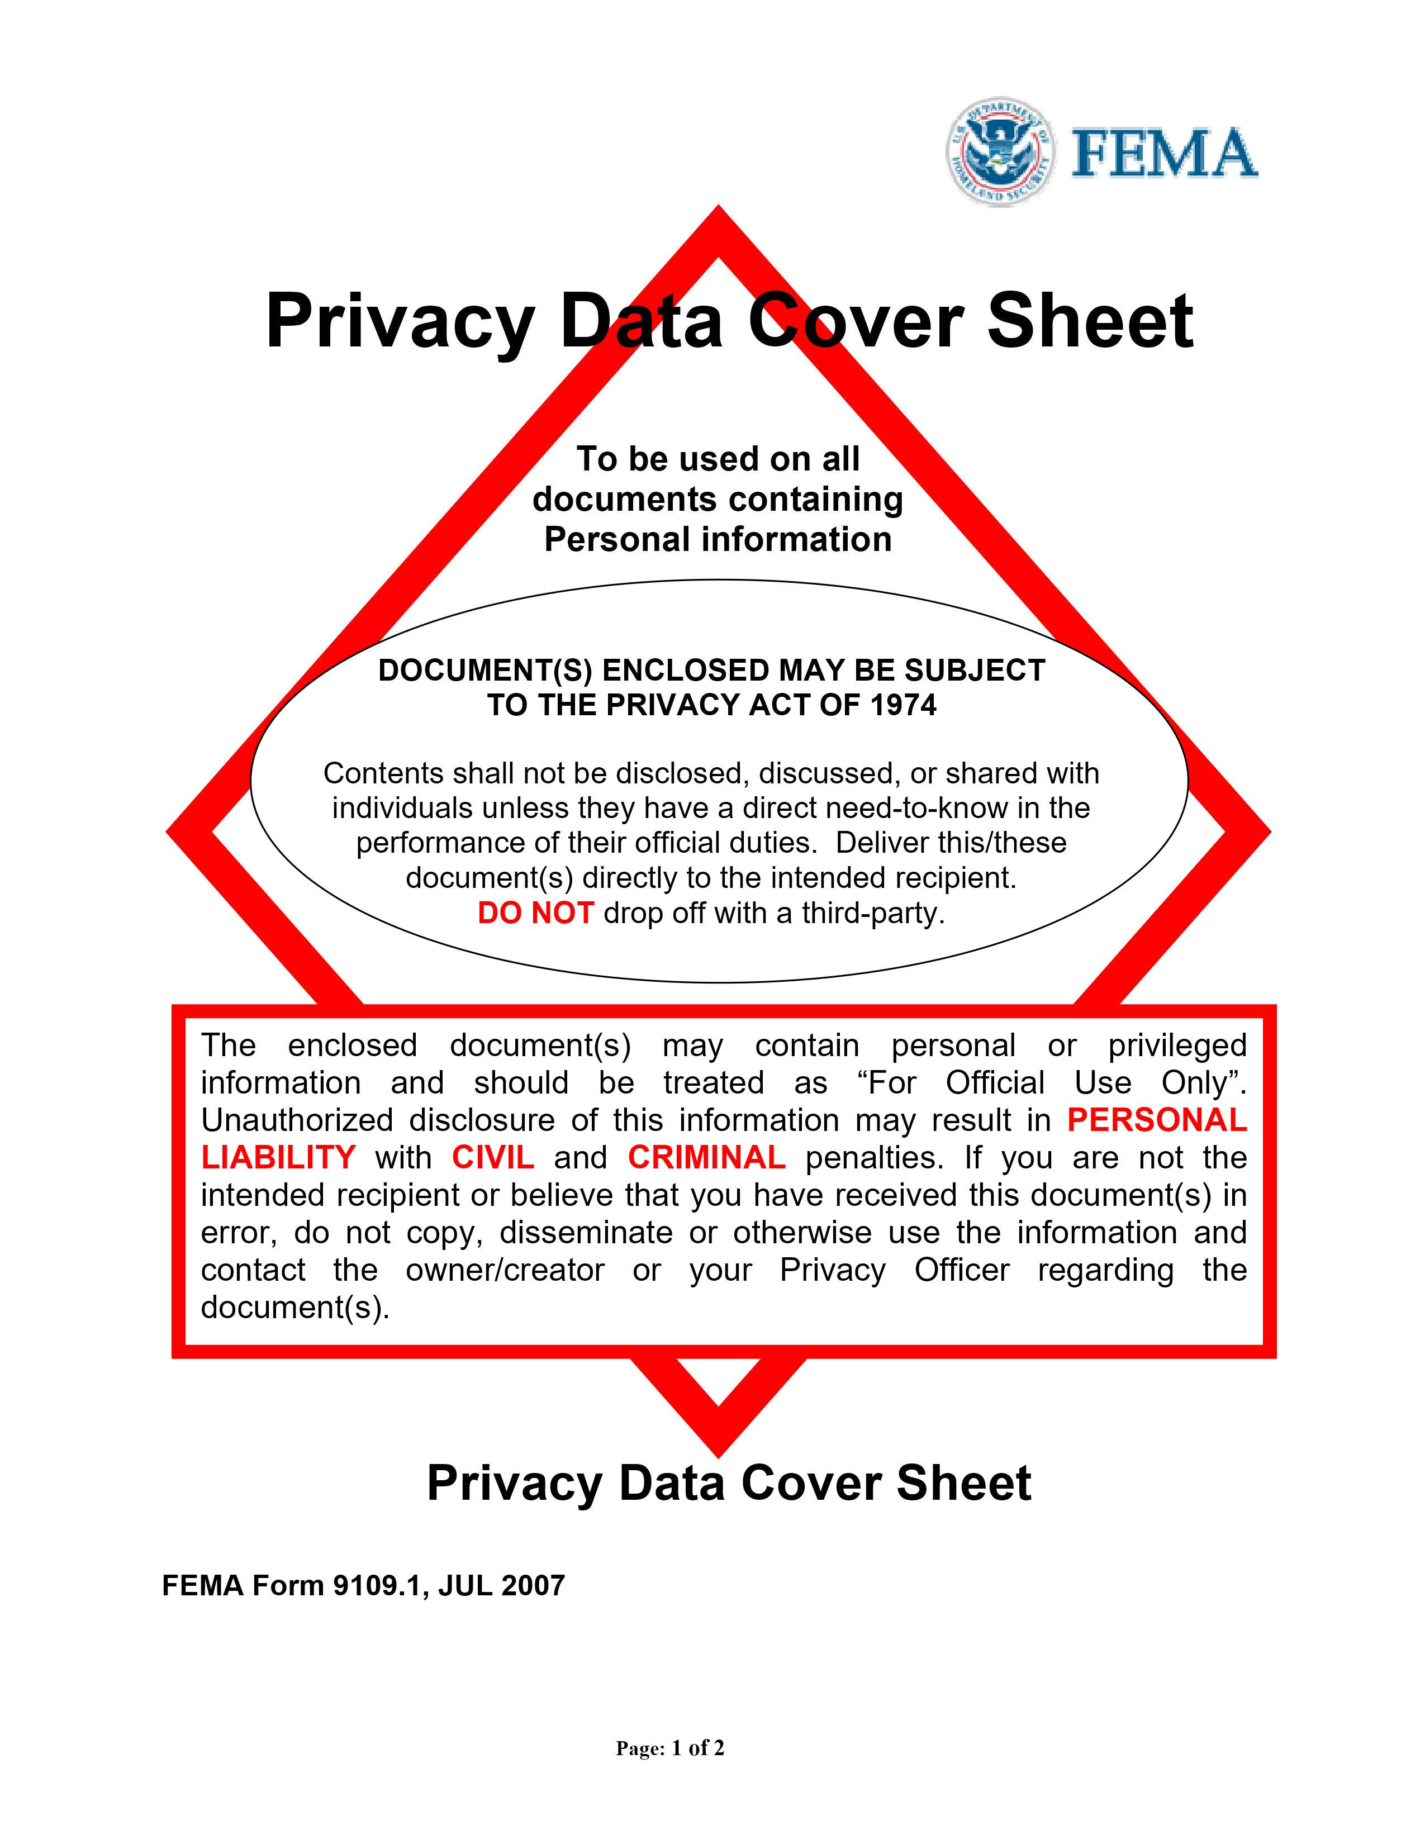

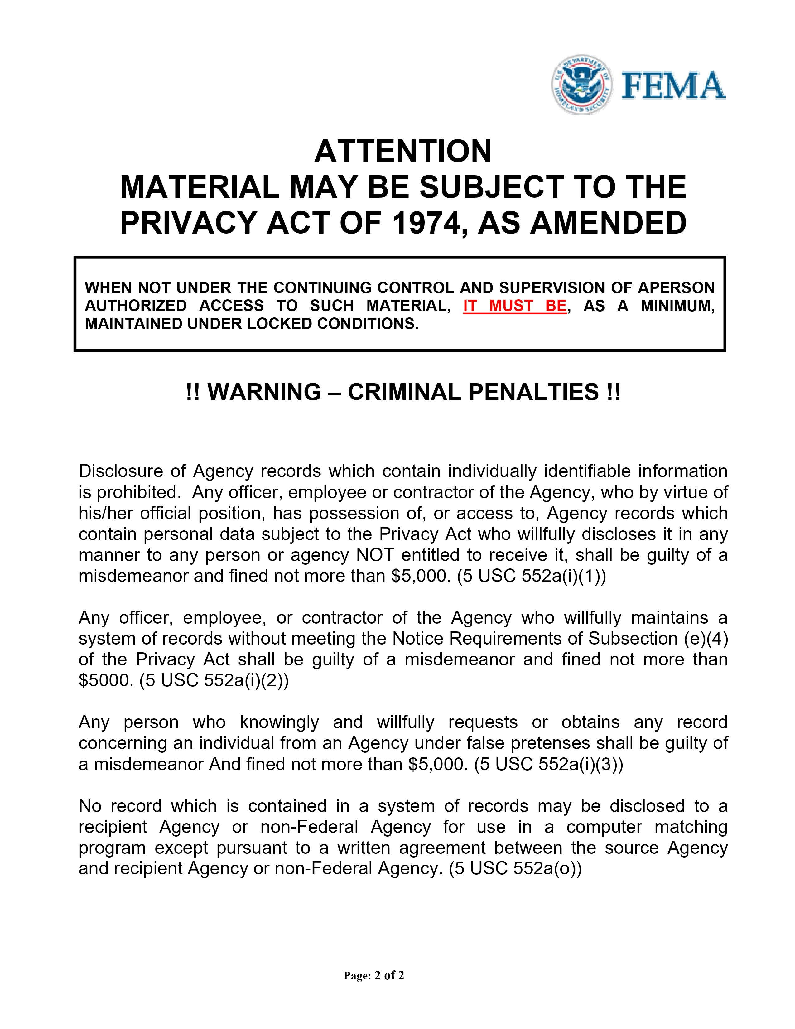

Remove this page before submitting

Insert signed FEMA Release of Information pages (2)

FEMA Release of Information form:
https://www.fema.gov/sites/default/files/documents/fema_form_ff-104-fy-21-118.pdf

Applicant Name: Applicant First M. Last
FEMA Registration No.: 6########
Disaster No.: DR-4860-KY (Kentucky Severe Storms, Straight-line Winds, Flooding, Landslides, and Mudslides)
Pre-disaster Address: Physical address, City, County, KY Zip
Post-disaster Address: Physical address, City, County, KY Zip
Mailing Address: Mailing address, City, County, KY Zip
Applicant Phone No.: 606-###-####
Date of Appeal: Month Day, 2025

HOUSING ASSISTANCE APPEAL LETTER

FEMA,

I, Applicant First M. Last, am appealing the amount/denial that I received for FEMA Housing Assistance, requesting a waiver of the 60-day appeal window, if applicable, and requesting an additional in-person home inspection.

I am requesting a waiver of the 60-day appeal window, if applicable, because I retained an attorney for assistance with my FEMA appeal and/or have been under significant stress working through the disaster recovery process.

I am requesting an in-person home inspection because I do not have adequate cell phone service for a remote/virtual damage assessment.

My primary residence was damaged on or about February 14, 2025 by DR-4860-KY (Kentucky Severe Storms, Straight-line Winds, Flooding, Landslides, and Mudslides). I am appealing the decision I received regarding my application for FEMA Housing Assistance.

I have enclosed supporting documentation with my appeal letter.

Please reconsider me for the maximum amount of Housing Assistance available to help me repair/replace my home to a safe, sanitary, and habitable condition. Please waive the 60-day appeal window, if applicable, and provide an additional in-person home inspection.

I hereby declare under penalty of perjury that the foregoing is true and correct.

Applicant Signature: __________________________________________

Applicant Printed Name: __________________________________________

OR ELECTRONIC SIGNATURE:

/s/ Applicant First M. Last

Applicant Name: Applicant First M. Last
FEMA Registration No.: 6########
Disaster No.: DR-4860-KY (Kentucky Severe Storms, Straight-line Winds, Flooding, Landslides, and Mudslides)
Pre-disaster Address: Physical address, City, County, KY Zip
Post-disaster Address: Physical address, City, County, KY Zip
Mailing Address: Mailing address, City, County, KY Zip
Applicant Phone No.: 606-###-####
Date of Appeal: Month Day, 2025

STATEMENT DECLARING I DID HAVE HOMEOWNERS INSURANCE COVERAGE
AT THE TIME OF THE DISASTER

I, Applicant First M. Last, did have homeowners insurance at the time of DR-4860-KY (Kentucky Severe Storms, Straight-line Winds, Flooding, Landslides, and Mudslides).

- No insurance payment:
My homeowners insurance has refused to pay any money for the damage to my home and property because I did not have flood insurance. I have attached my homeowners insurance denial letter.

OR

- Some insurance payment:
My homeowners insurance has offered me a settlement check in the amount of $0.00 to pay for the damage to my home. This amount does not cover the replacement cost of all damages to my home and essential personal property that was destroyed or needs repair due to DR-4860-KY. I have attached a copy of my homeowners insurance settlement check.

I hereby declare under penalty of perjury that the foregoing is true and correct.

Applicant Signature: __________________________________________

Applicant Printed Name: __________________________________________

OR ELECTRONIC SIGNATURE:

/s/ Applicant First M. Last

Remove this page before submitting

Insert homeowners insurance documents here

Example:
- Homeowners Insurance Denial Letter
- Homeowners Insurance Declaration Pages
- Homeowners Insurance Settlement Check Copy

Applicant Name: Applicant First M. Last
FEMA Registration No.: 6########
Disaster No.: DR-4860-KY (Kentucky Severe Storms, Straight-line Winds, Flooding, Landslides, and Mudslides)
Pre-disaster Address: Physical address, City, County, KY Zip
Post-disaster Address: Physical address, City, County, KY Zip
Mailing Address: Mailing address, City, County, KY Zip
Applicant Phone No.: 606-###-####
Date of Appeal: Month Day, 2025

FINAL PAGE OF APPEAL

This page has been intentionally left blank.

