FAX
To: | FEMA Individuals and Households Program | From: | Applicant First M. Last
Fax: | (800) 827-8112 | Fax: | 606-###-####
Phone: | (800) 621-3362 | Phone: | 606-###-####
Subject: | Proof of Ownership/Occupancy  of Mobile Home Appeal Letter | Date: | Month Day, 2025
No. Pages: | ____ (Including Cover Sheet)

Comments:

Applicant Name: Applicant First M. Last
FEMA Registration No.: 6########
Disaster No.: DR-4860-KY (Kentucky Severe Storms, Straight-line Winds, Flooding, Landslides, and Mudslides)
Pre-disaster Address: Physical address, City, County, KY Zip
Post-disaster Address: Physical address, City, County, KY Zip
Mailing Address: Mailing address, City, County, KY Zip
Applicant Phone No.: 606-###-####
Date of Appeal: Month Day, 2025

Attachments:

- Signed Release of Information Form
- Proof of Ownership/Occupancy of Mobile Home Appeal Letter
- Sworn Self-Declaration of Ownership/Occupancy of Mobile Home
- Supporting Document
- Supporting Document
- Supporting Document
- FEMA’s September 2, 2021 Memorandum, SUBJECT: Amendment to FP 104-009-03, Individual Assistance Program and Policy Guide, Version 1.1

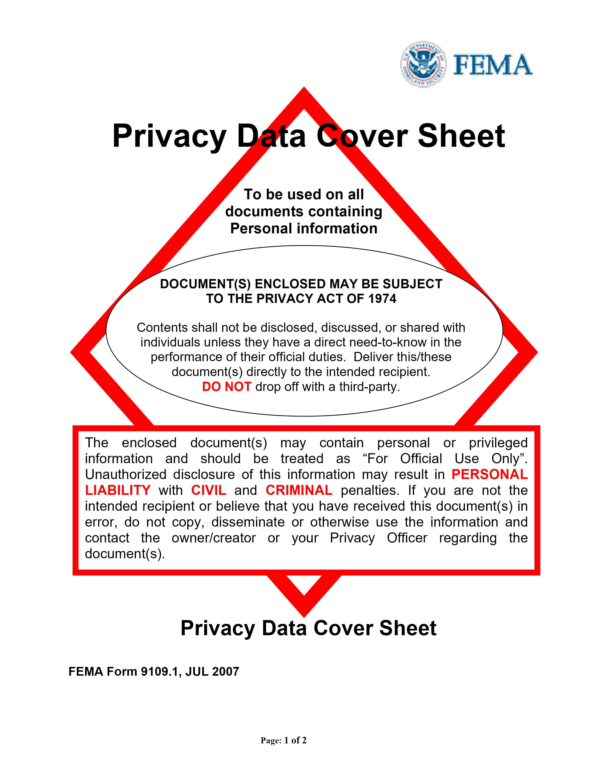
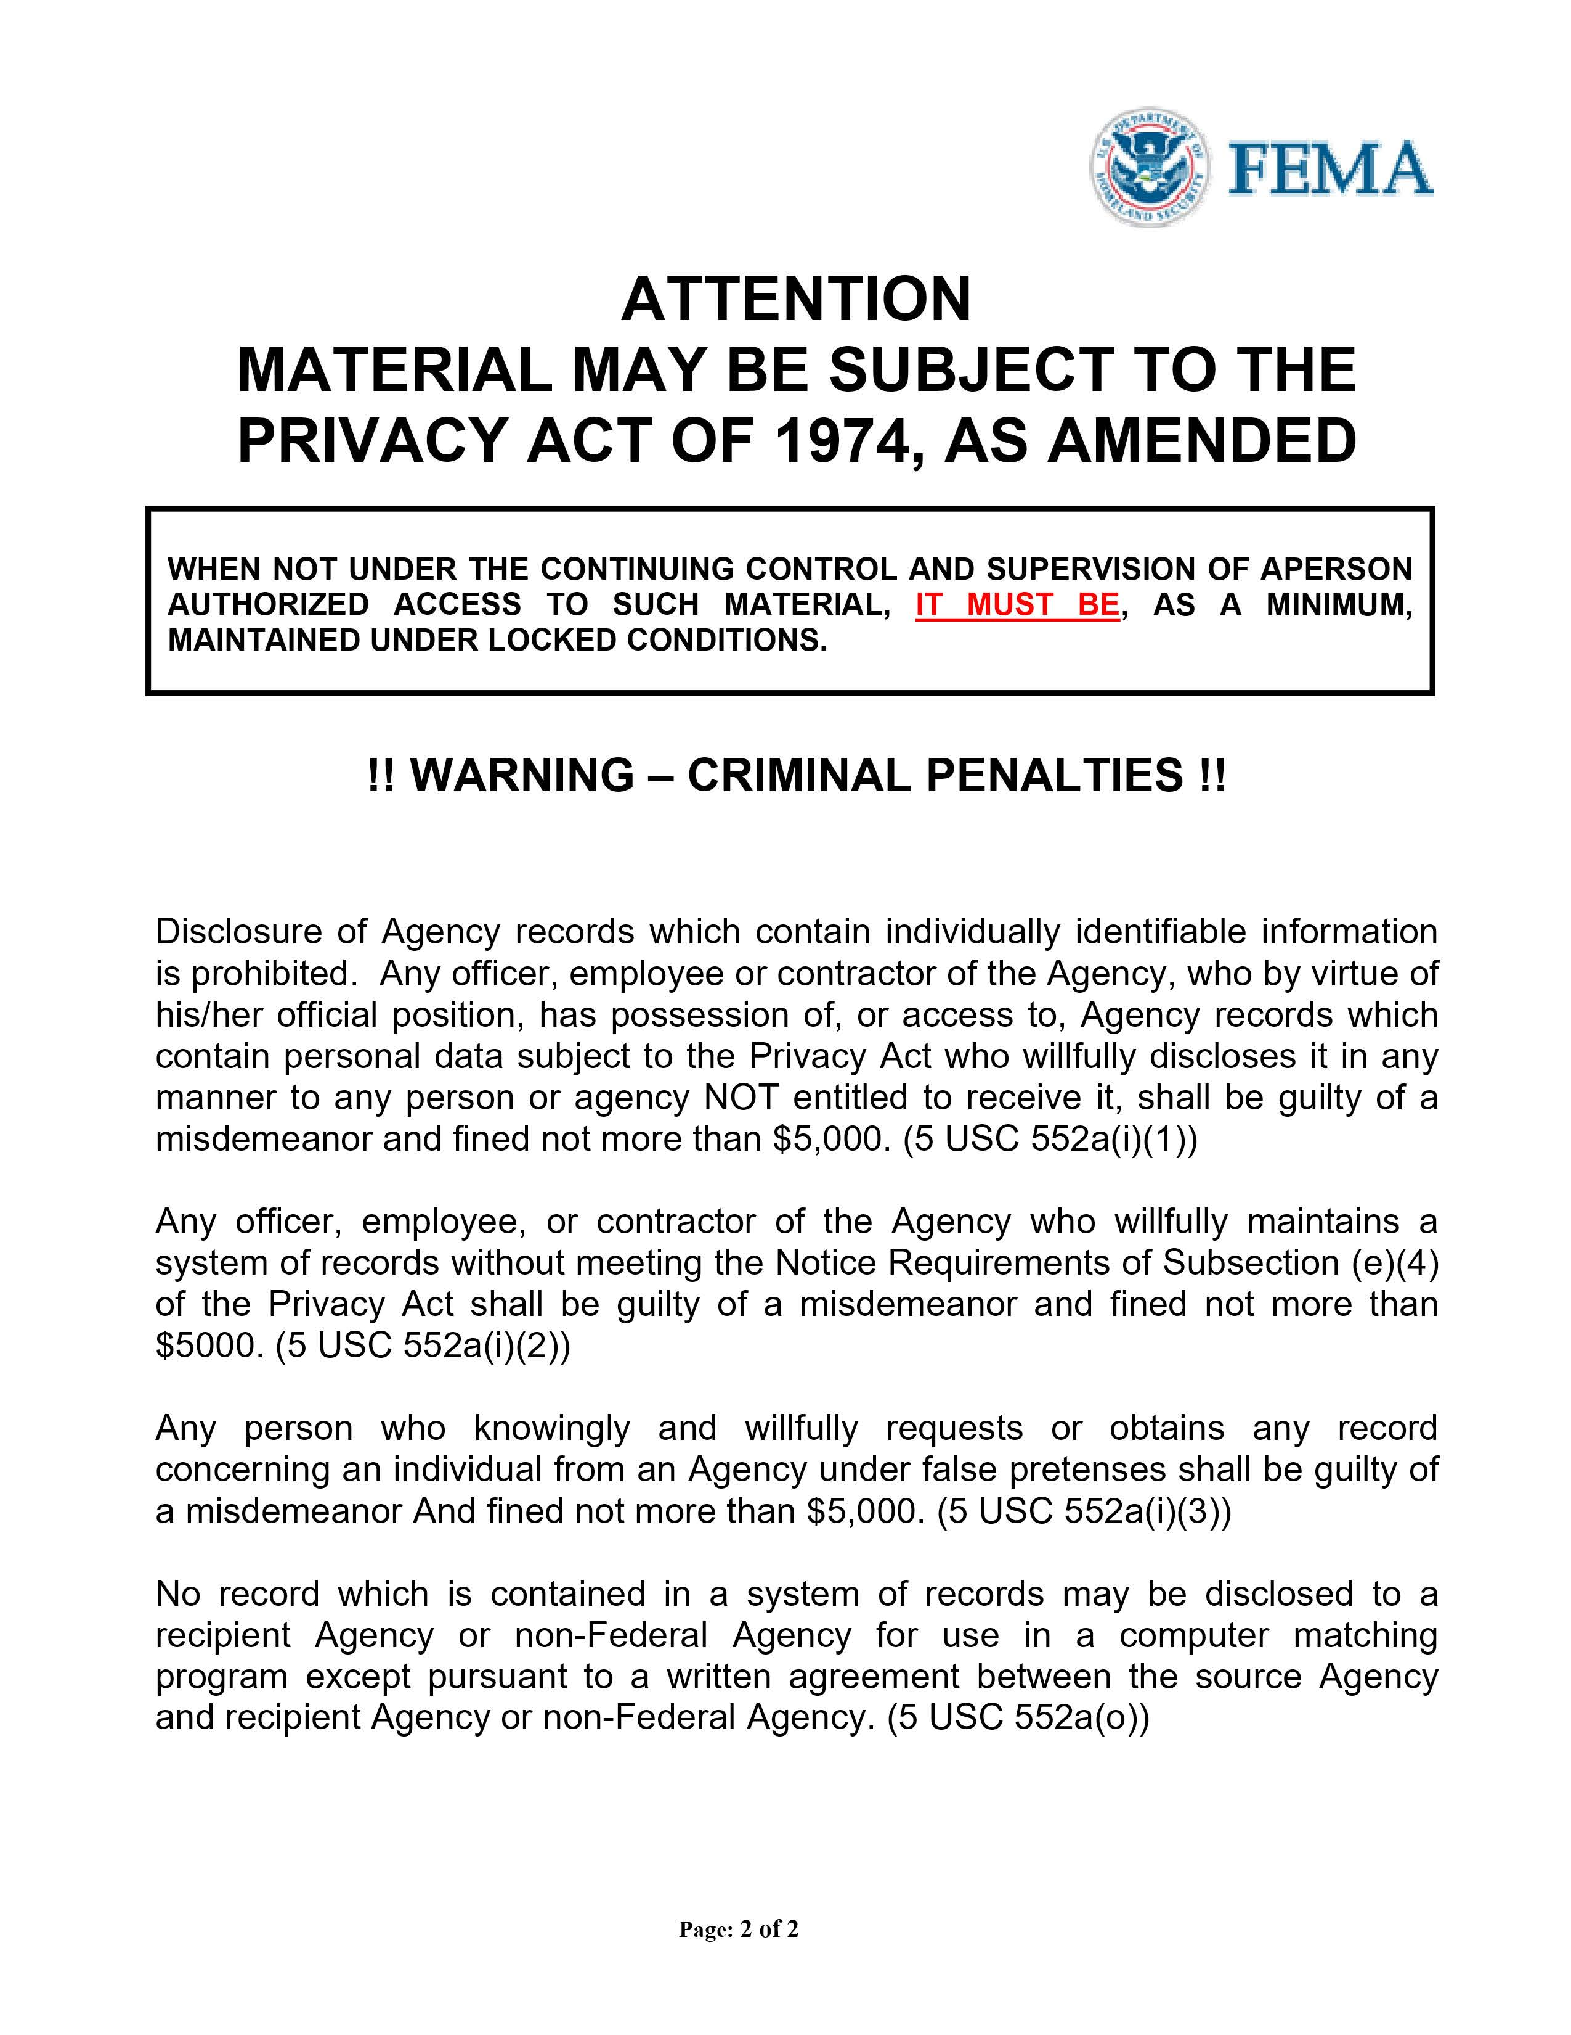

Remove this page before submitting

Insert signed FEMA Release of Information pages (2)

FEMA Release of Information form:
https://www.fema.gov/sites/default/files/documents/fema_form_ff-104-fy-21-118.pdf

Applicant Name: Applicant First M. Last
FEMA Registration No.: 6########
Disaster No.: DR-4860-KY (Kentucky Severe Storms, Straight-line Winds, Flooding, Landslides, and Mudslides)
Pre-disaster Address: Physical address, City, County, KY Zip
Post-disaster Address: Physical address, City, County, KY Zip
Mailing Address: Mailing address, City, County, KY Zip
Applicant Phone No.: 606-###-####
Date of Appeal: Month Day, 2025

PROOF OF OWNERSHIP/OCCUPANCY OF MOBILE HOME APPEAL LETTER

FEMA:

I, First M. Last, was denied Housing Assistance for my damaged home at Physical address, City, County, Kentucky Zip because ownership/occupancy was not verified. I am appealing the decision and providing acceptable proof of ownership/occupancy pursuant to FEMA’s September 2, 2021 Memorandum, SUBJECT: Amendment to FP 104-009-03, Individual Assistance Program and Policy Guide, Version 1.1 (“the Memorandum”) addressed below and attached to this letter. If applicable, please waive the 60-day appeal window because I have been trying to obtain acceptable documentation.

I have made a good faith effort to obtain and provide a copy of acceptable ownership/occupancy documentation. I have been unable to obtain this documentation because I have been under significant stress working through the disaster recovery process and because my pre-disaster residence was a mobile home or travel trailer.

The Documentation to Verify Occupancy on pages 2-5 and Documentation to Verify Ownership on pages 6-8 of the Memorandum state that FEMA will accept alternative documentation of ownership and/or occupancy if FEMA is unable to verify same through a public records search. I have attached the following documentation with my appeal letter:

- Supporting Document
- Supporting Document
- Supporting Document

The Documentation Exceptions section on page 8 of the Memorandum states that “FEMA will accept a written self-declarative statement as a last resort from applicants whose pre-disaster residence was a mobile home or travel trailer…” As such, I have also attached a signed self-declarative statement.

Please waive the 60-day appeal window, if applicable, and provide an additional home inspection. Please reconsider me for the maximum amount of Housing Assistance and Other Needs/Personal Property Assistance for the damages to my primary disaster-damaged residence and personal property due to DR-4860-KY (Kentucky Severe Storms, Straight-line Winds, Flooding, Landslides, and Mudslides).

I hereby declare under penalty of perjury that the foregoing is true and correct.

Sincerely,

Applicant Signature: __________________________________________
Applicant Printed Name: __________________________________________
Applicant Name: Applicant First M. Last
FEMA Registration No.: 6########
Disaster No.: DR-4860-KY (Kentucky Severe Storms, Straight-line Winds, Flooding, Landslides, and Mudslides)
Pre-disaster Address: Physical address, City, County, KY Zip
Post-disaster Address: Physical address, City, County, KY Zip
Mailing Address: Mailing address, City, County, KY Zip
Applicant Phone No.: 606-###-####
Date of Appeal: Month Day, 2025

SWORN SELF-DECLARATION OF OWNERSHIP/OCCUPANCY OF MOBILE HOME

I, First M. Last, affirm the following:

- I own the disaster-damaged mobile home or travel trailer at Physical address, City, County, Kentucky Zip and make this declaration for the purpose of appealing my denial for Housing Assistance because ownership was not proven.

- I have lived at my disaster-damaged mobile home or travel trailer since Approximate Date, approximately # Years/Months prior to the Presidential disaster declaration DR-4860-KY (Kentucky Severe Storms, Straight-line Winds, Flooding, Landslides, and Mudslides).

- I have made a good faith effort, in coordination with FEMA, to obtain and provide a copy of acceptable ownership/occupancy documentation. I have been unable to obtain this documentation because my disaster-damaged home was a mobile home or travel trailer. As such, I was unable to obtain traditional forms of ownership/occupancy documentation.

- I meet FEMA’s definition of an owner-occupant because I am the legal owner of the home, I pay no rent for the home, I am responsible for the maintenance for the residence and property taxes, and I hold lifetime occupancy rights.

I hereby declare under penalty of perjury that the foregoing is true and correct.

Applicant Signature: __________________________________________

Applicant Printed Name: __________________________________________

Remove this page before submitting

Insert alternative supporting documents proving ownership and/or occupancy

List of alternative occupancy documents: Documentation to Verify Occupancy Chart.docx

List of alternative ownership documents: Documentation to Verify Ownership Chart.docx

Remove this page before submitting

Insert entire FEMA September 2021 Ownership and Occupancy Memo
(link below)

https://www.fema.gov/sites/default/files/documents/fema_individual-assistance-program-and-policy-guide-iappg-policy-amendments-memo-9.2.21_signed.pdf

Applicant Name: Applicant First M. Last
FEMA Registration No.: 6########
Disaster No.: DR-4860-KY (Kentucky Severe Storms, Straight-line Winds, Flooding, Landslides, and Mudslides)
Pre-disaster Address: Physical address, City, County, KY Zip
Post-disaster Address: Physical address, City, County, KY Zip
Mailing Address: Mailing address, City, County, KY Zip
Applicant Phone No.: 606-###-####
Date of Appeal: Month Day, 2025

FINAL PAGE OF APPEAL

This page has been intentionally left blank.

