FAX
To: | FEMA Individuals and Households Program | From: | Applicant First M. Last
Fax: | 800-827-8112 | Fax: | 606-###-####
Phone: | 800-621-3362 | Phone: | 606-###-####
Subject: | Proof of Ownership via Heirship  Appeal Letter | Date: | Month Day, 2025
No. Pages: | ____ (Including Cover Sheet)

Comments:

Applicant Name: Applicant First M. Last
FEMA Registration No.: 6########
Disaster No.: DR-4860-KY (Kentucky Severe Storms, Straight-line Winds, Flooding, Landslides, and Mudslides)
Pre-disaster Address: Physical address, City, County, KY Zip
Post-disaster Address: Physical address, City, County, KY Zip
Mailing Address: Mailing address, City, County, KY Zip
Applicant Phone No.: 606-###-####
Date of Appeal: Month Day, 2025

Attachments:

- Signed Release of Information Form
- Proof of Ownership via Heirship Appeal Letter
- Sworn Self-Declaration of Ownership via Heirship
- Supporting Document
- Supporting Document
- Supporting Document
- FEMA’s September 2, 2021 Memorandum, SUBJECT: Amendment to FP 104-009-03, Individual Assistance Program and Policy Guide, Version 1.1

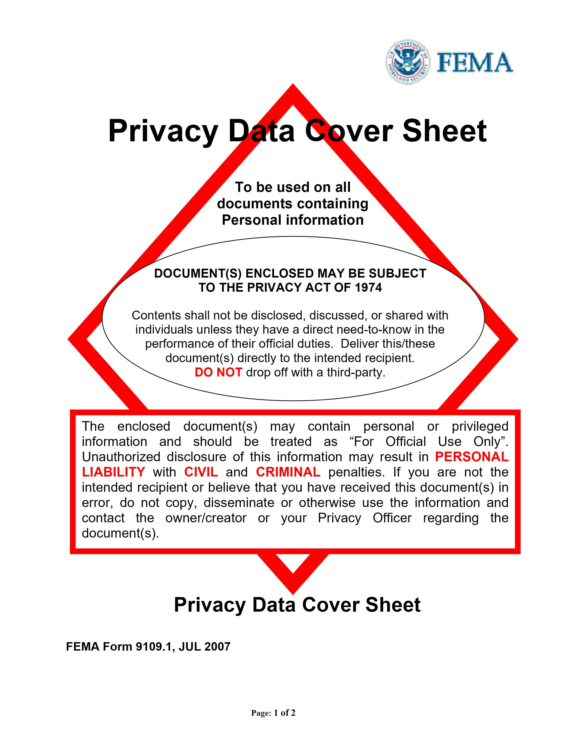
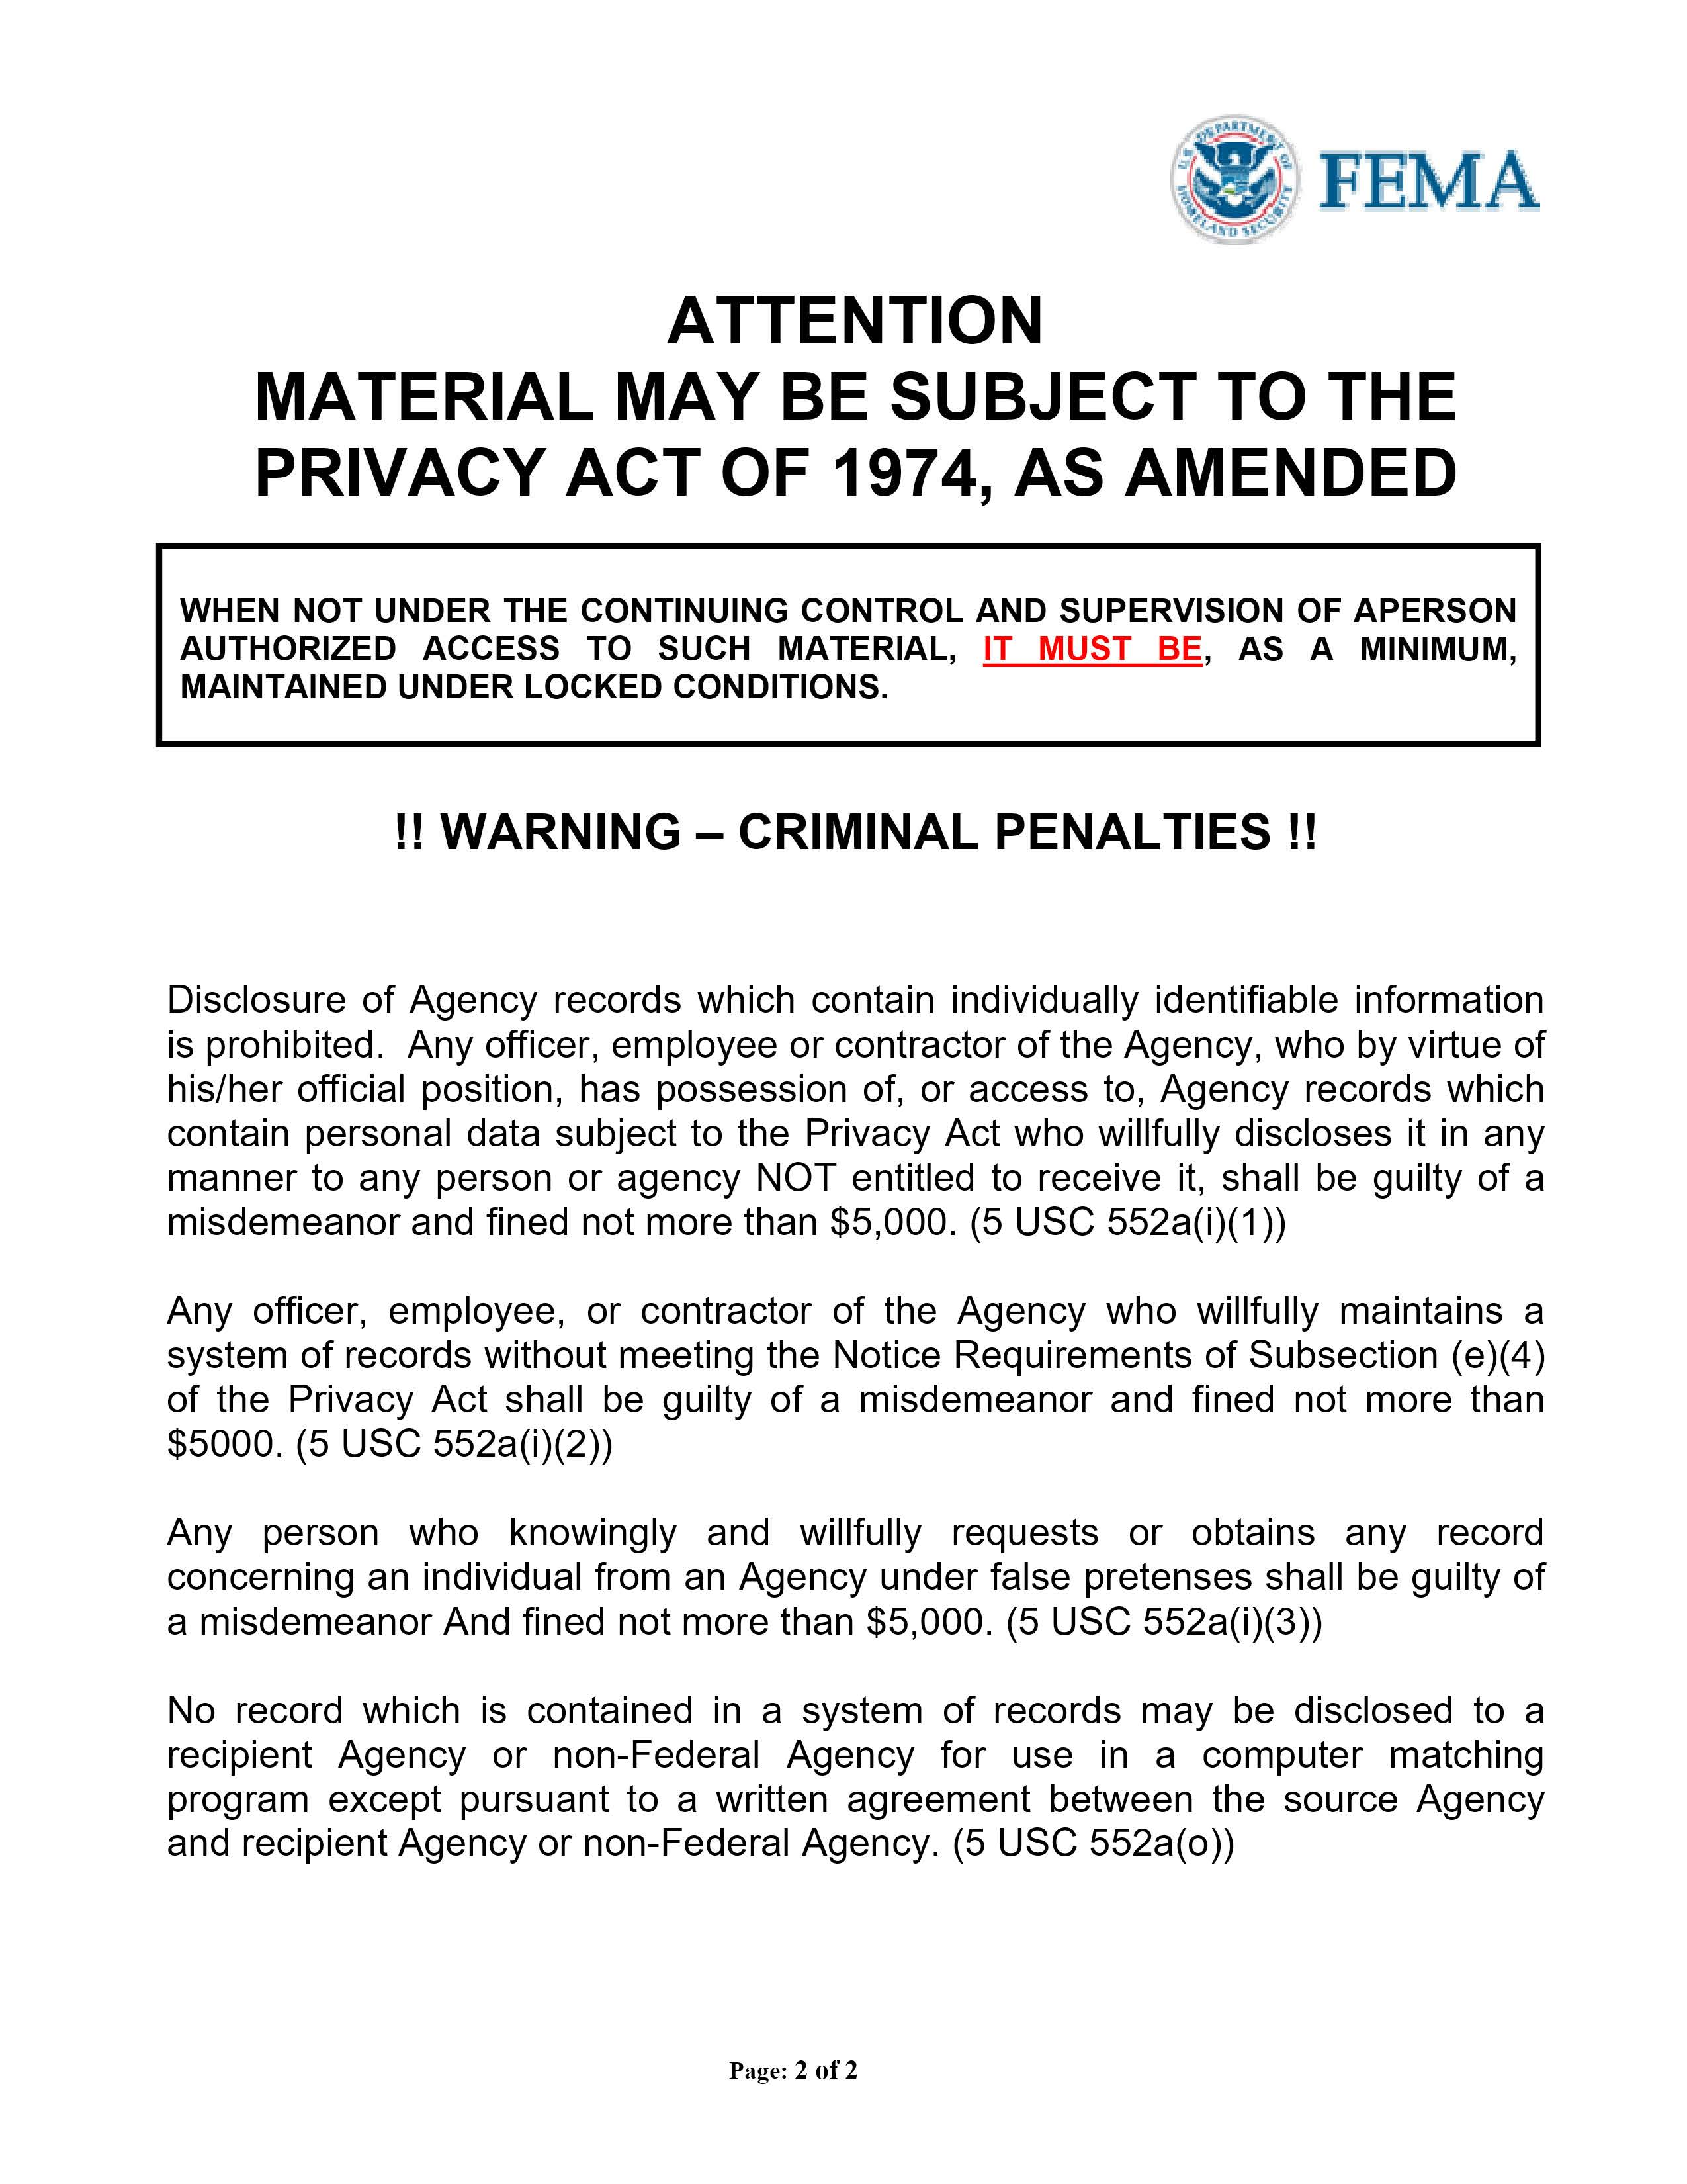

Remove this page before submitting

Insert signed FEMA Release of Information pages (2)

FEMA Release of Information form:
https://www.fema.gov/sites/default/files/documents/fema_form_ff-104-fy-21-118.pdf

Applicant Name: Applicant First M. Last
FEMA Registration No.: 6########
Disaster No.: DR-4860-KY (Kentucky Severe Storms, Straight-line Winds, Flooding, Landslides, and Mudslides)
Pre-disaster Address: Physical address, City, County, KY Zip
Post-disaster Address: Physical address, City, County, KY Zip
Mailing Address: Mailing address, City, County, KY Zip
Applicant Phone No.: 606-###-####
Date of Appeal: Month Day, 2025

PROOF OF OWNERSHIP VIA HEIRSHIP APPEAL LETTER

FEMA:

I, First M. Last, was denied Housing Assistance for my damaged home at Physical address, City, County, Kentucky Zip because ownership was not verified. I am appealing the decision and providing acceptable proof of ownership pursuant to FEMA’s September 2, 2021 Memorandum, SUBJECT: Amendment to FP 104-009-03, Individual Assistance Program and Policy Guide, Version 1.1 (“the Memorandum”) addressed below and attached hereto. If applicable, please waive the 60-day appeal window because I have been trying to obtain acceptable documentation.

I have made a good faith effort to obtain and provide a copy of acceptable ownership documentation. I have been unable to obtain this documentation because my pre-disaster residence was passed down via heirship from my relationship to Applicant, Decedent’s first and last name. E.g. my father, John Smith.

The Documentation to Verify Occupancy on pages 2-5 and Documentation to Verify Ownership on pages 6-8 of the Memorandum state that FEMA will accept alternative documentation of ownership and/or occupancy if FEMA is unable to verify same through a public records search. I have attached the following documentation with my appeal letter:

- Supporting Document
- Supporting Document
- Supporting Document

The Documentation Exceptions section on page 8 of the Memorandum states that FEMA will accept “a written self-declarative statement . . . from applicants whose pre-disaster residence was passed down via heirship, as often times, traditional forms of ownership documentation in these situations do not exist . . .” As such, I have also attached a signed self-declarative statement.

Please waive the 60-day appeal window, if applicable, and provide an additional home inspection. Please reconsider me for the maximum amount of Housing Assistance and Other Needs/Personal Property Assistance for the damages to my primary disaster-damaged residence and personal property due to DR-4860-KY (Kentucky Severe Storms, Straight-line Winds, Flooding, Landslides, and Mudslides).

I hereby declare under penalty of perjury that the foregoing is true and correct.

Sincerely,

Applicant Signature: __________________________________________

Applicant Printed Name: __________________________________________
Applicant Name: Applicant First M. Last
FEMA Registration No.: 6########
Disaster No.: DR-4860-KY (Kentucky Severe Storms, Straight-line Winds, Flooding, Landslides, and Mudslides)
Pre-disaster Address: Physical address, City, County, KY Zip
Post-disaster Address: Physical address, City, County, KY Zip
Mailing Address: Mailing address, City, County, KY Zip
Applicant Phone No.: 606-###-####
Date of Appeal: Month Day, 2025

SWORN SELF-DECLARATION OF OWNERSHIP VIA HEIRSHIP

I, First M. Last, affirm the following:

- I own the disaster-damaged home at Physical address, City, County, Kentucky Zip and make this declaration for the purpose of appealing my denial for Housing Assistance because ownership was not proven.

- I have lived at my disaster-damaged home since Approximate Date, approximately # Years/Months prior to the Presidential disaster declaration DR-4860-KY (Kentucky Severe Storms, Straight-line Winds, Flooding, Landslides, and Mudslides).

- I have made a good faith effort, in coordination with FEMA, to obtain and provide a copy of acceptable ownership documentation. I have been unable to obtain this documentation because provide a short explanation of the circumstances that prevent standard ownership verification. As such, I was unable to obtain traditional forms of ownership documentation.

- As the nearest relative of the deceased in the line of succession, my ownership includes all the rights and obligations of the deceased. The decedent’s name is Decedent’s First and Last Name who died on date of death.

- I meet FEMA’s definition of an owner-occupant because I am the legal owner of the home, I pay no rent, I am responsible for the maintenance for the residence and property taxes, and I hold lifetime occupancy rights.

I hereby declare under penalty of perjury that the foregoing is true and correct.

Applicant Signature: __________________________________________

Applicant Printed Name: __________________________________________

Date: ________________

Remove this page before submitting

Insert alternative supporting documents proving ownership and/or occupancy

List of alternative occupancy documents: Documentation to Verify Occupancy Chart.docx

List of alternative ownership documents: Documentation to Verify Ownership Chart.docx

Remove this page before submitting

Insert entire FEMA September 2021 Ownership and Occupancy Memo
(link below)

https://www.fema.gov/sites/default/files/documents/fema_individual-assistance-program-and-policy-guide-iappg-policy-amendments-memo-9.2.21_signed.pdf

Applicant Name: Applicant First M. Last
FEMA Registration No.: 6########
Disaster No.: DR-4860-KY (Kentucky Severe Storms, Straight-line Winds, Flooding, Landslides, and Mudslides)
Pre-disaster Address: Physical address, City, County, KY Zip
Post-disaster Address: Physical address, City, County, KY Zip
Mailing Address: Mailing address, City, County, KY Zip
Applicant Phone No.: 606-###-####
Date of Appeal: Month Day, 2025

FINAL PAGE OF APPEAL

This page has been intentionally left blank.

