FAX
To: | FEMA Individuals and Households Program | From: | Applicant First M. Last
Fax: | 800-827-8112 | Fax: | 606-###-####
Phone: | 800-621-3362 | Phone: | 606-###-####
Subject: | Proof of Ownership/Occupancy  Appeal Letter | Date: | Month Day, 2025
No. Pages: | ____ (Including Cover Sheet)

Comments:

Applicant Name: Applicant First M. Last
FEMA Registration No.: 6########
Disaster No.: DR-4860-KY (Kentucky Severe Storms, Straight-line Winds, Flooding, Landslides, and Mudslides)
Pre-disaster Address: Physical address, City, County, KY Zip
Post-disaster Address: Physical address, City, County, KY Zip
Mailing Address: Mailing address, City, County, KY Zip
Applicant Phone No.: 606-###-####
Date of Appeal: Month Day, 2025

Attachments:

- Signed Release of Information Form
- Proof of Ownership/Occupancy Appeal Letter
- Supporting Document
- Supporting Document
- Supporting Document
- FEMA’s September 2, 2021 Memorandum, SUBJECT: Amendment to FP 104-009-03, Individual Assistance Program and Policy Guide, Version 1.1

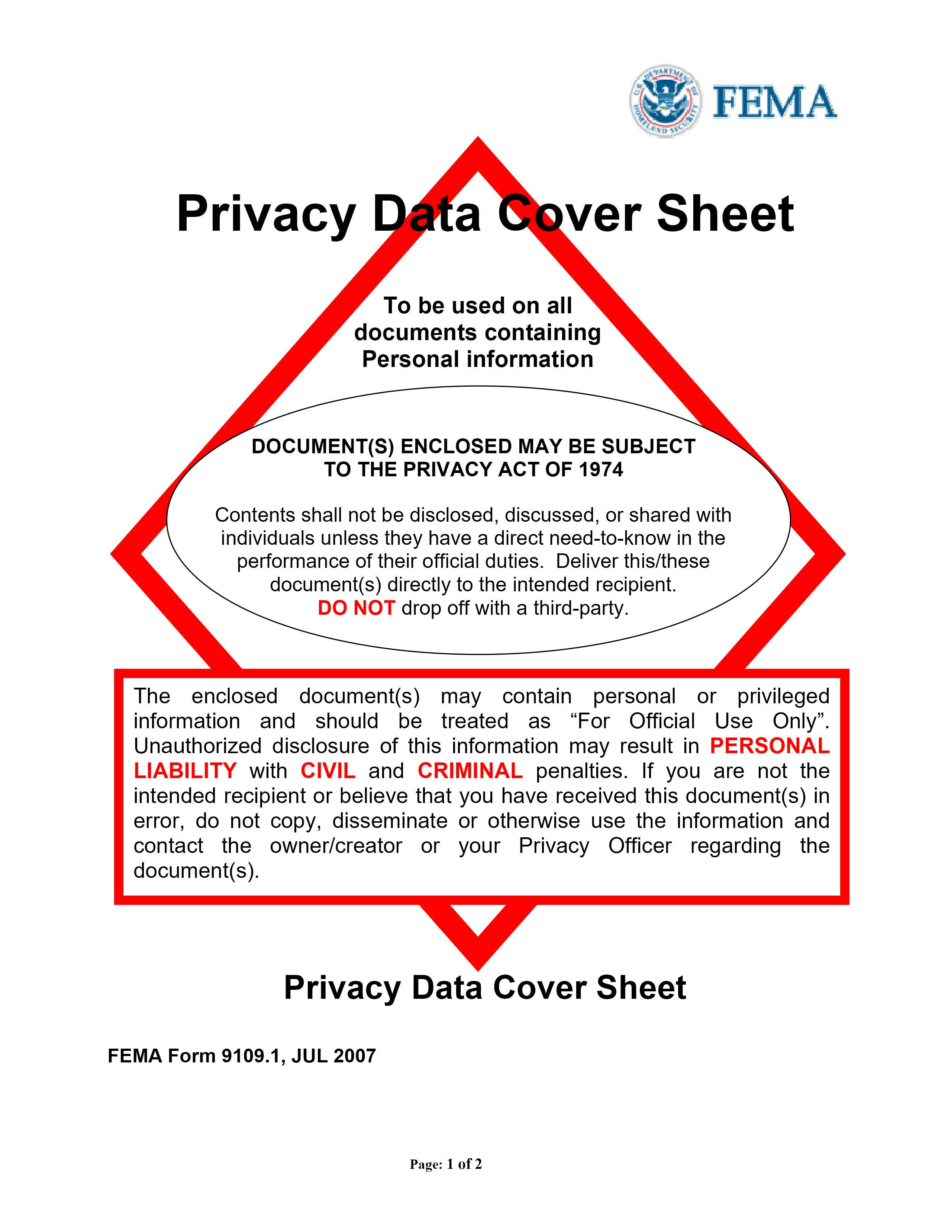
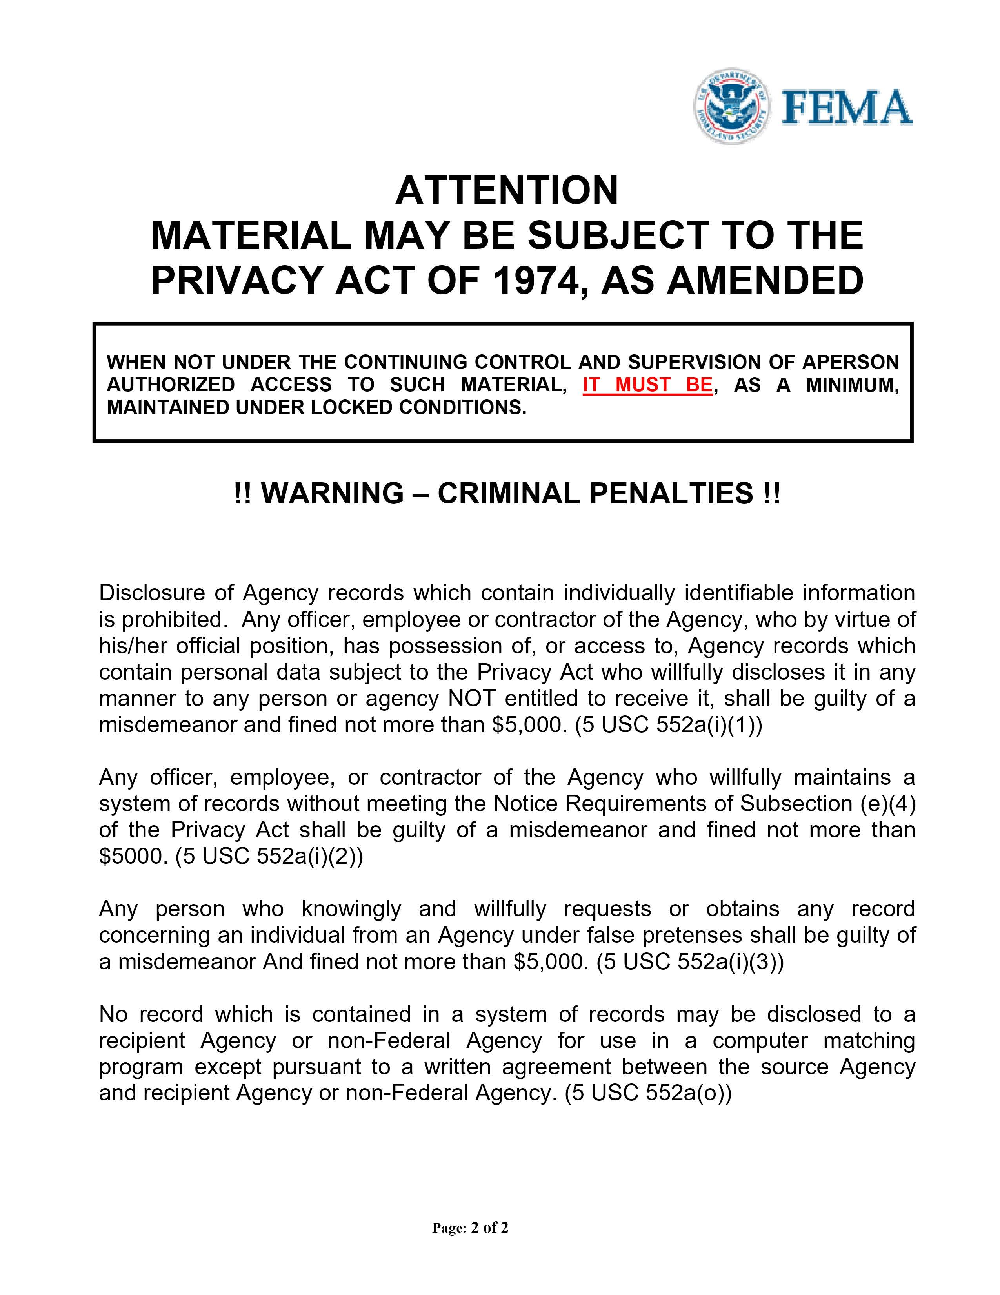

Remove this page before submitting

Insert signed FEMA Release of Information pages (2)

FEMA Release of Information form:
https://www.fema.gov/sites/default/files/documents/fema_form_ff-104-fy-21-118.pdf

Applicant Name: Applicant First M. Last
FEMA Registration No.: 6########
Disaster No.: DR-4860-KY (Kentucky Severe Storms, Straight-line Winds, Flooding, Landslides, and Mudslides)
Pre-disaster Address: Physical address, City, County, KY Zip
Post-disaster Address: Physical address, City, County, KY Zip
Mailing Address: Mailing address, City, County, KY Zip
Applicant Phone No.: 606-###-####
Date of Appeal: Month Day, 2025

PROOF OF OWNERSHIP/OCCUPANCY APPEAL LETTER

FEMA:

I, First M. Last, was denied Housing Assistance for my damaged home at Physical address, City, County, Kentucky Zip because ownership/occupancy was not verified. I am appealing the decision and providing acceptable proof of ownership/occupancy pursuant to FEMA’s September 2, 2021 Memorandum, SUBJECT: Amendment to FP 104-009-03, Individual Assistance Program and Policy Guide, Version 1.1 (“the Memorandum”) addressed below and attached to this letter. If applicable, please waive the 60-day appeal window because I have been trying to obtain acceptable documentation.

I have made a good faith effort to obtain and provide a copy of acceptable ownership/occupancy documentation. I have been unable to obtain this documentation because I have been under significant stress working through the disaster recovery process.

The Documentation to Verify Occupancy on pages 2-5 and Documentation to Verify Ownership on pages 6-8 of the Memorandum state that FEMA will accept alternative documentation of ownership and/or occupancy if FEMA is unable to verify same through a public records search. I have attached the following documentation with my appeal letter:

- Supporting Document
- Supporting Document
- Supporting Document

Please waive the 60-day appeal window, if applicable, and provide an additional home inspection. Please reconsider me for the maximum amount of Housing Assistance and Other Needs/Personal Property Assistance for the damages to my primary disaster-damaged residence and personal property due to DR-4860-KY (Kentucky Severe Storms, Straight-line Winds, Flooding, Landslides, and Mudslides).

I hereby declare under penalty of perjury that the foregoing is true and correct.

Sincerely,

Applicant Signature: __________________________________________

Applicant Printed Name: __________________________________________

OR ELECTRONIC SIGNATURE:

/s/ Applicant First M. Last

Remove this page before submitting

Insert alternative supporting documents proving ownership and/or occupancy

List of alternative occupancy documents: Documentation to Verify Occupancy Chart.docx

List of alternative ownership documents: Documentation to Verify Ownership Chart.docx

Remove this page before submitting

Insert entire FEMA September 2021 Ownership and Occupancy Memo
(link below)

https://www.fema.gov/sites/default/files/documents/fema_individual-assistance-program-and-policy-guide-iappg-policy-amendments-memo-9.2.21_signed.pdf

Applicant Name: Applicant First M. Last
FEMA Registration No.: 6########
Disaster No.: DR-4860-KY (Kentucky Severe Storms, Straight-line Winds, Flooding, Landslides, and Mudslides)
Pre-disaster Address: Physical address, City, County, KY Zip
Post-disaster Address: Physical address, City, County, KY Zip
Mailing Address: Mailing address, City, County, KY Zip
Applicant Phone No.: 606-###-####
Date of Appeal: Month Day, 2025

FINAL PAGE OF APPEAL

This page has been intentionally left blank.

