**FEMA RELEASE OF INFORMATION FORM**

1. **Fill out FEMA Release of Information (ROI) form**
   1. A close-up of a document

      AI-generated content may be incorrect.Complete top section of ROI with Applicant’s information. It is strongly recommended to include the FEMA Applicant Number even though the ROI shows “optional.”
   2. **Section A**: Include Applicant name and any authorized representative or family member the Applicant may wish to communicate with FEMA on the Applicant’s behalf.

* 1. **Section B**: Authorizes any name listed in Section A and/or organization listed in Section C to request information. Applicant may cross out and initial any part of either statement that they do not wish to share. It is recommended to check “yes” to all three options. Write or type “**3. Other: Request for my entire FEMA case file.**”

* 1. A screen shot of a computer screen

     AI-generated content may be incorrect.**Section C**: Resources for unmet needs assisting with Applicant’s recovery. Marking “No” will require a new Release of Information form if resources become available down the road. Write or type in “**5. Other**” any additional organizations or individuals the Applicant may wish to communicate with FEMA on the Applicant’s behalf.
  2. Applicant must sign and print their full name. Do not sign as “Chris” if full name is “Christopher.” Write or type current physical address and date.

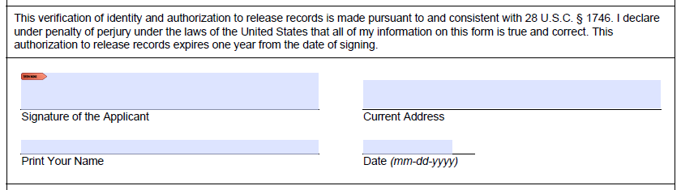

* 1. Release of Information forms are valid for one year from the date signed, or until the Applicant wishes to change part or all their ROI.

1. **Submit signed ROI to FEMA**
   1. Faxto 800-827-8112 or upload to the Applicant’s DisasterAssistance.gov account.
2. **Confirm FEMA received ROI**
   1. Call the FEMA Helpline at 800-621-3362 five-ten days after submitting to confirm that FEMA received the Applicant’s ROI and added to the Applicant’s account.