**FREE DISASTER LEGAL SERVICES HOTLINE**

For disaster survivors that can’t afford legal help

**1-844-478-0099**

**☑ FEMA ☑ SBA ☑ Landlord/Tenant**

**☑ Scams ☑ Disability ☑ Contracts**

Get help with disaster legal issues like:

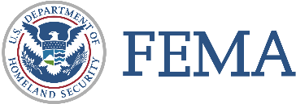

**CALL 1-844-478-0099   
TO FIND FREE LEGAL HELP**

Low-income people impacted by the disaster may qualify for free legal help with issues like:

**☑ FEMA ☑ SBA ☑ Landlord/Tenant**

**☑ Scams ☑ Disability ☑ Contracts**